|  |  |
| --- | --- |
| Nikon Z5  Máy ảnh Nikon Z5 +Lens 24-200mm f/4-6.3  Nikon Z5 with lens 24-200 1 Nikon Z5 with lens 24-200 2 Nikon Z5 1 Nikon Z5 2 | **Featured information:**  EXPEED 6 image processor  24.3MP CMOS sensor  3.6 million-dot OLED electronic viewfinder  Record UHD 4K and Full HD videos  Price : $ 2100  **Specifications:**  Lens Mount  Nikon Z  Sensor Format  Full-Frame (1x Crop Factor)  Resolution  24.3 Megapixels  Size photo  6016 x 4016  Image Proportions  1:1, 3:2, 16:9  Sensor Type  CMOS  Image Format  JPEG, Raw  Anti-Vibration  Sensor-Shift, 5-Axis |

**Overview:**

The Nikon Z5 possesses a 24.3MP full-frame CMOS sensor combined with the EXPEED 6 image processor to provide fast, accurate processing performance and high image quality. In addition, the ISO range of 100 - 51200 (expandable to 102400) allows users to take photos in all lighting conditions, enhancing noise control, providing clean and detailed photos. In addition, the EXPEED 6 processor also allows continuous shooting at 4.5 frames per second as well as the ability to capture 8MP when recording video.

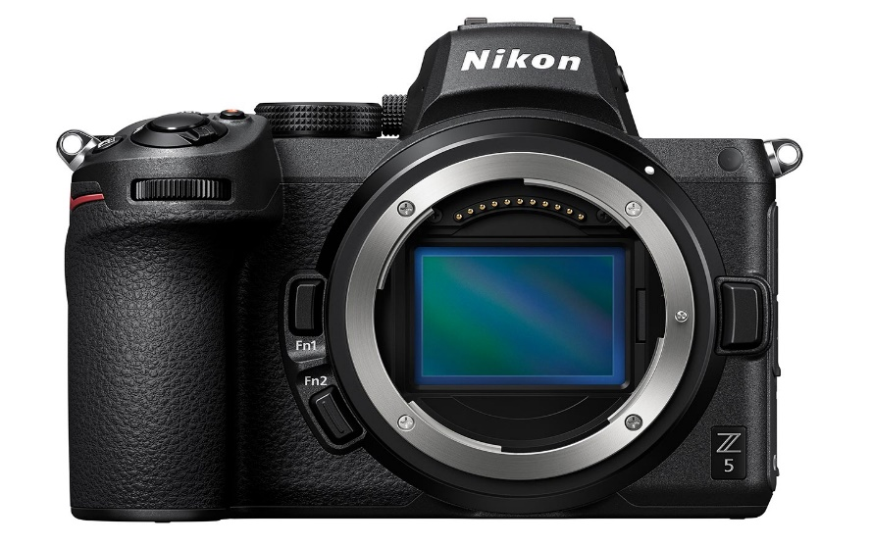

The Nikon Z5's sensor is also integrated with a 273-point Hybrid AF system, combining phase-detection focusing with contrast-based focusing, helping to improve focus speed quickly and accurately.

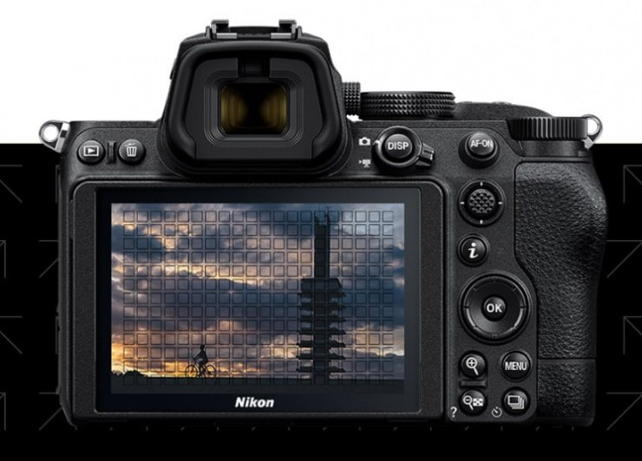

Not only does it take high-quality photos, the Nikon Z5 also supports UHD 4K video recording (1.7x crop) at up to 30 frames per second and Full-HD 1080p recording at a maximum speed of 60 frames per second. Users can choose the location to store video files on the device's internal memory card or external memory via HDMI output.

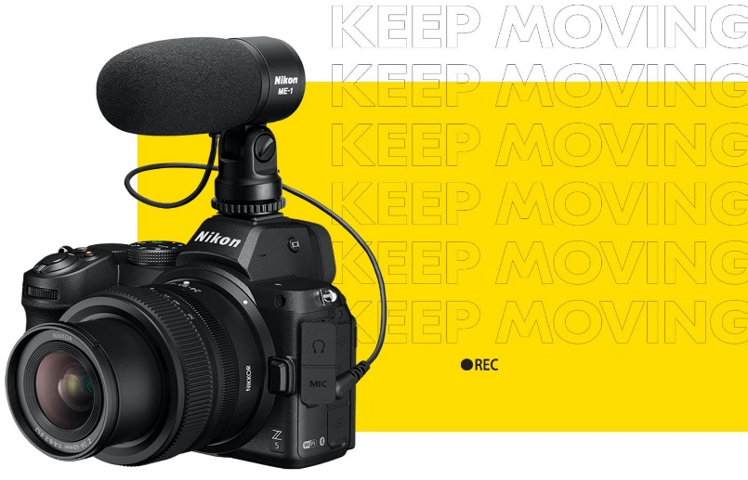

Integrated into the Nikon Z5 camera body is a 5-axis image stabilization system, supporting anti-shake up to 5 stops. In addition, to bring many benefits to video recording, electronic image stabilization is available in the camera to help make footage more stable.